# CAM as a Benchmark for FREVO components

Settings

CAM:

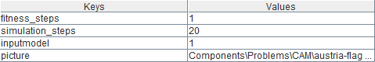

NNGA:

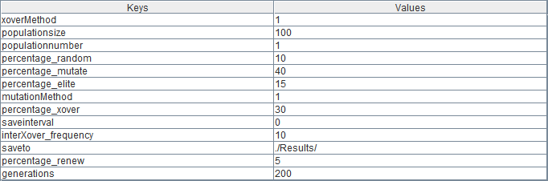

Fully connected neural network:

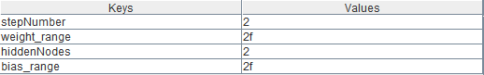

10 runs:

CAM:



NNGA:

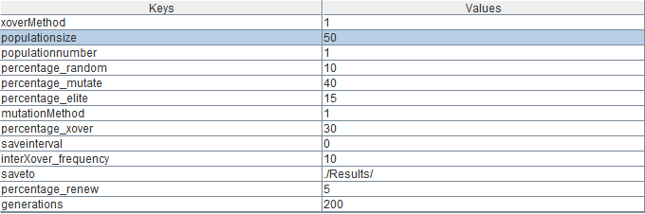

Fully connected neural network:



10 runs:

CAM:

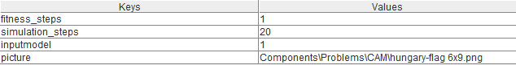

NNGA:



Fully connected neural network:



10 runs:

CAM:



NNGA:



Fully connected neural network:



10 runs: